**CENT4802 - ROMANIA BROWN**

**Screenshots for the Fibonacci Sequence task:**

1. Program Run Screenshot that shows the output of the program.

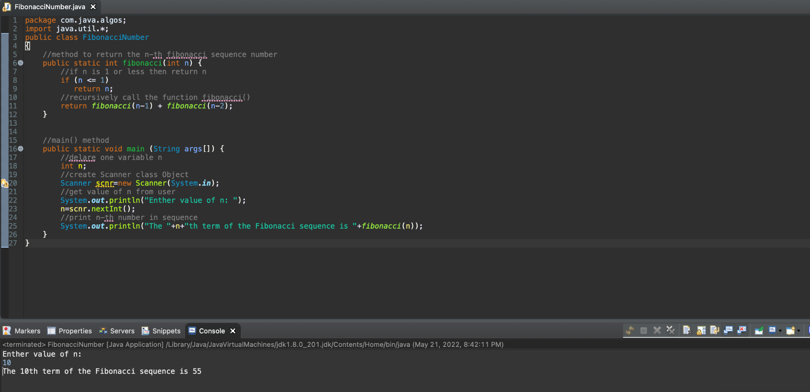

1. Initial Commit Screenshot

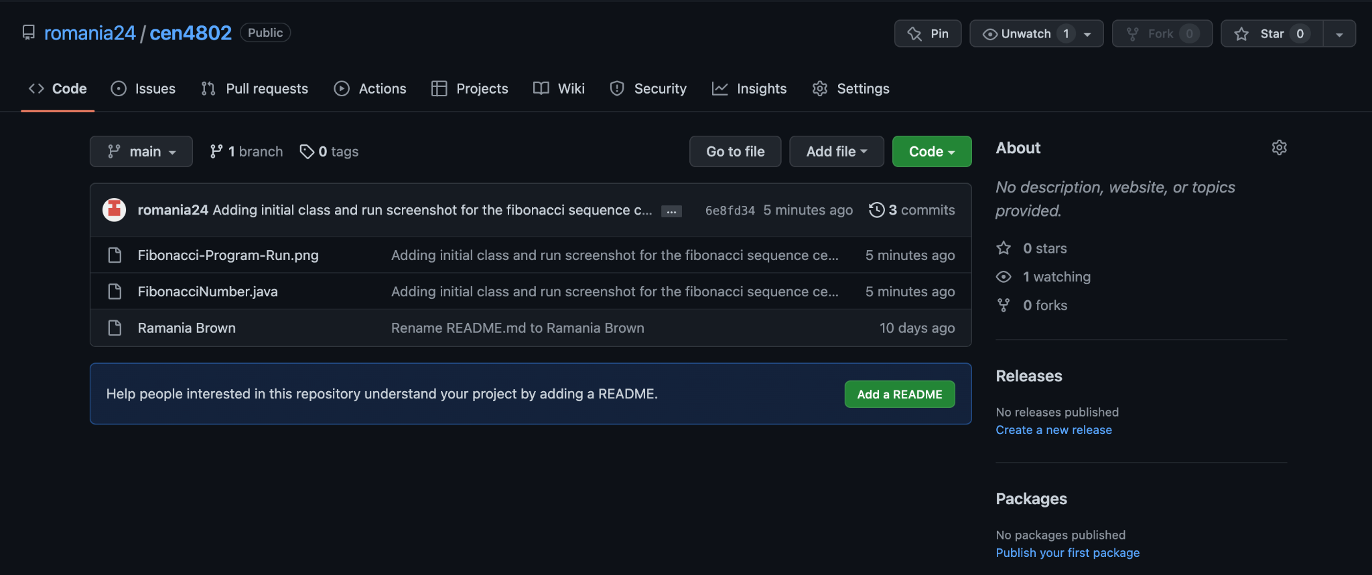

1. New Branch created for the issue.

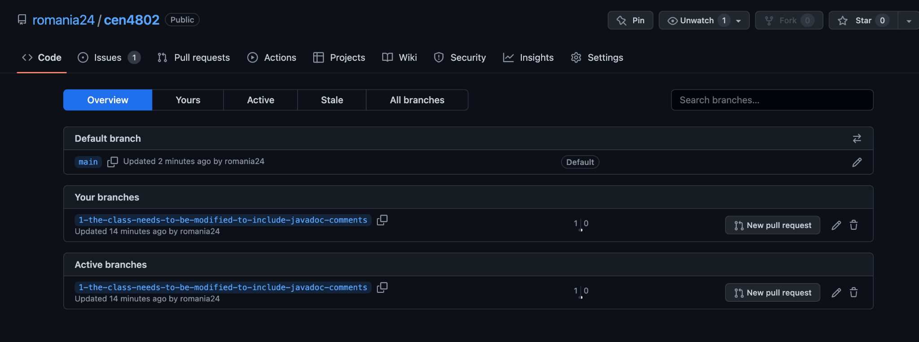

1. New Issue Created.

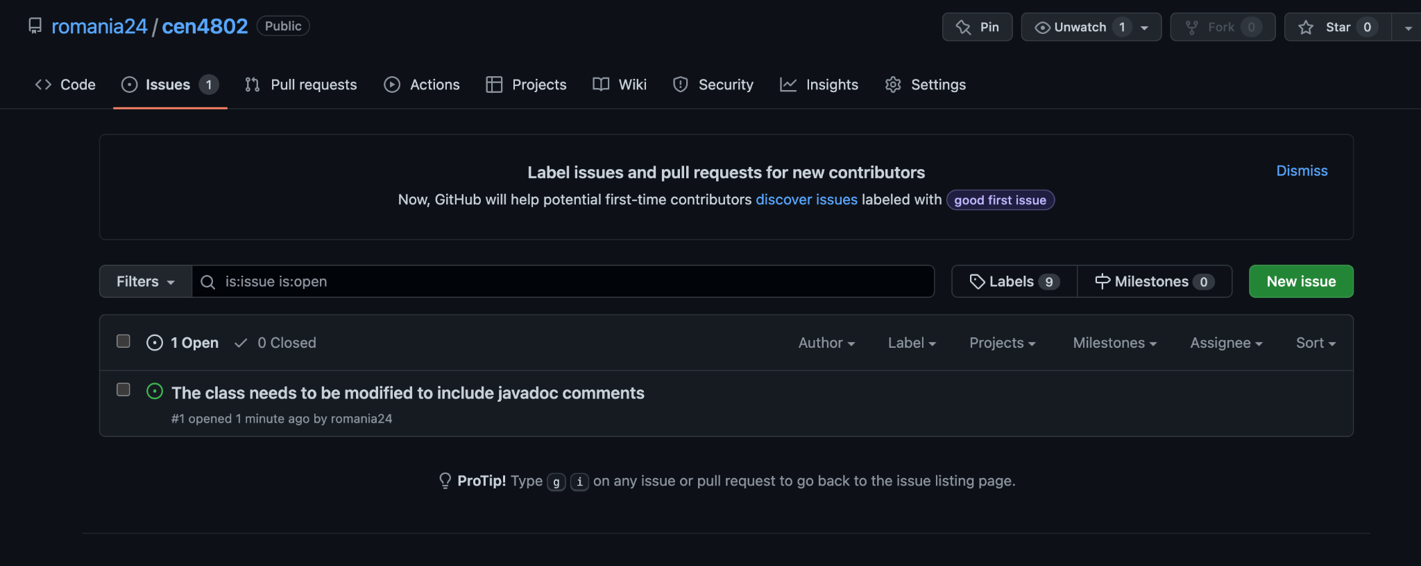

1. Updated class screenshot on the new branch created.

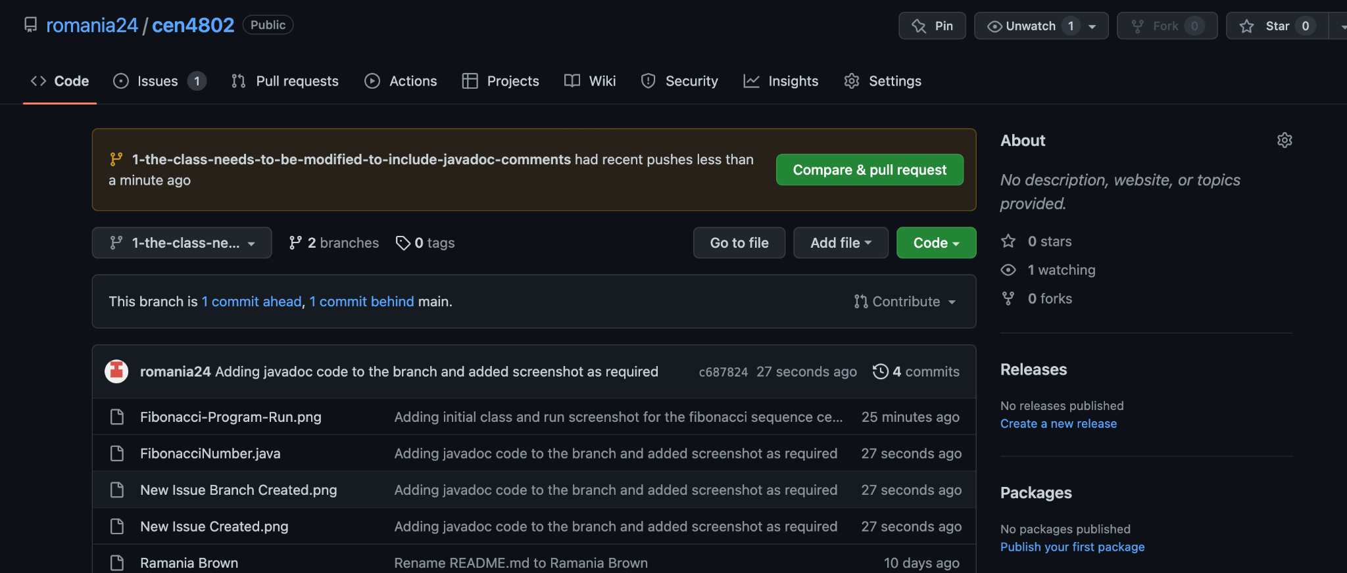

1. First screenshot of the Pull Request created.

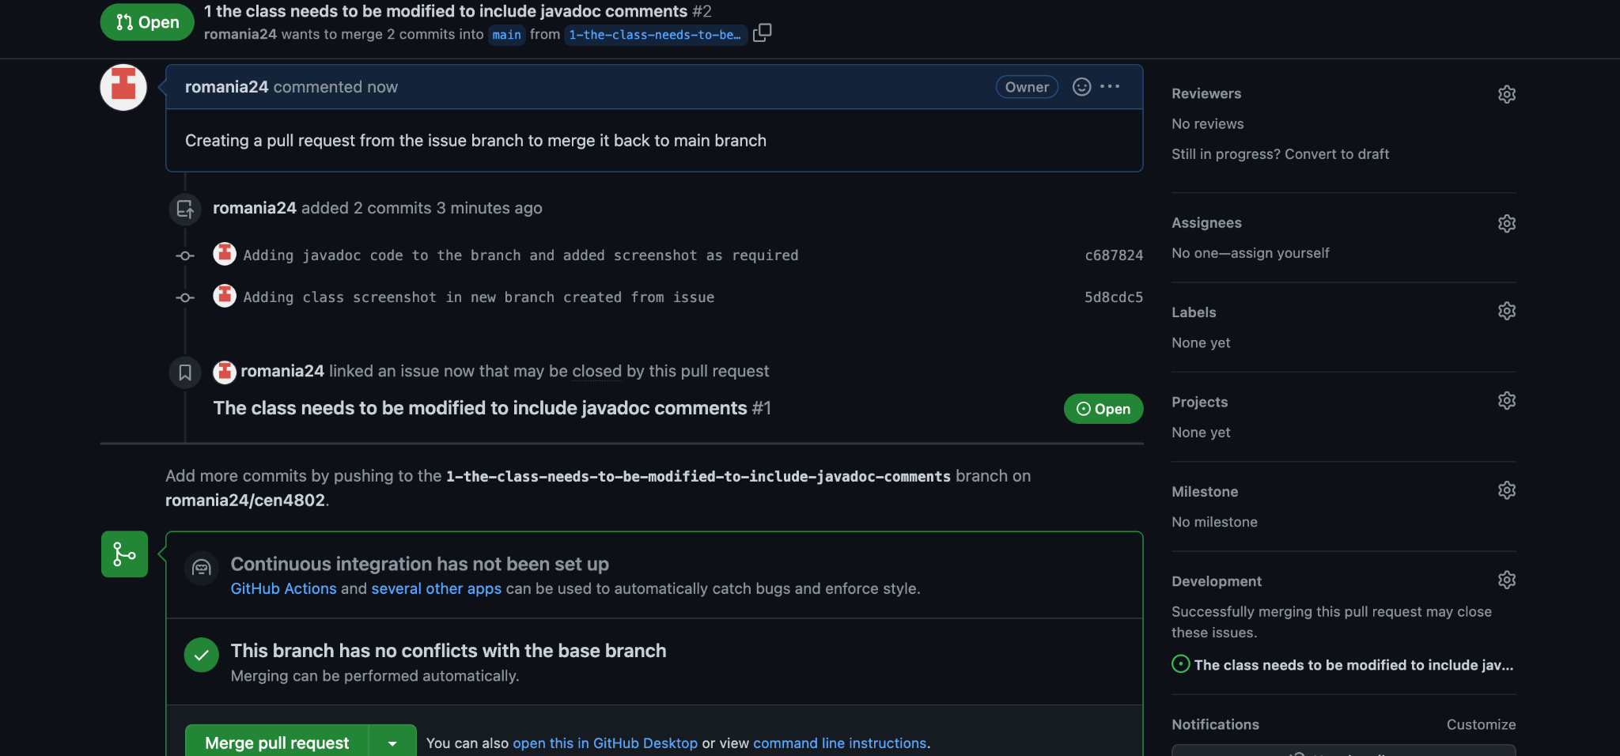

1. Pull request comparison screenshot

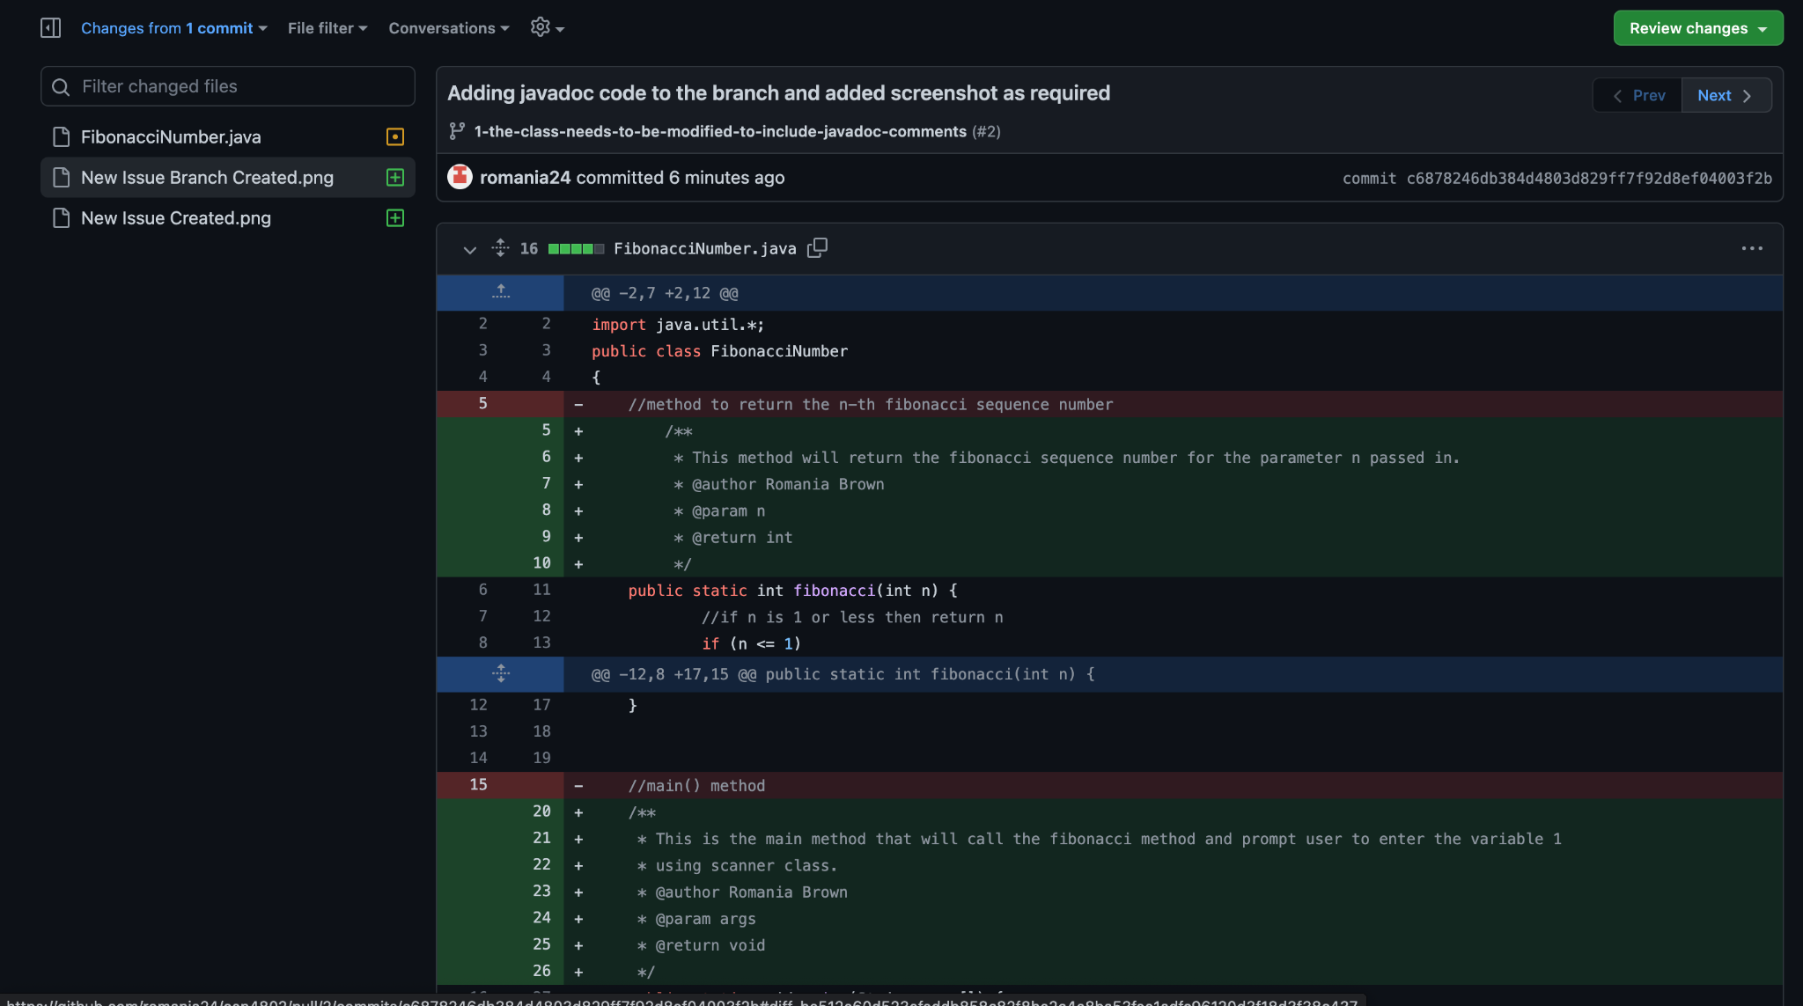

1. Pull request comparison with markup tool.

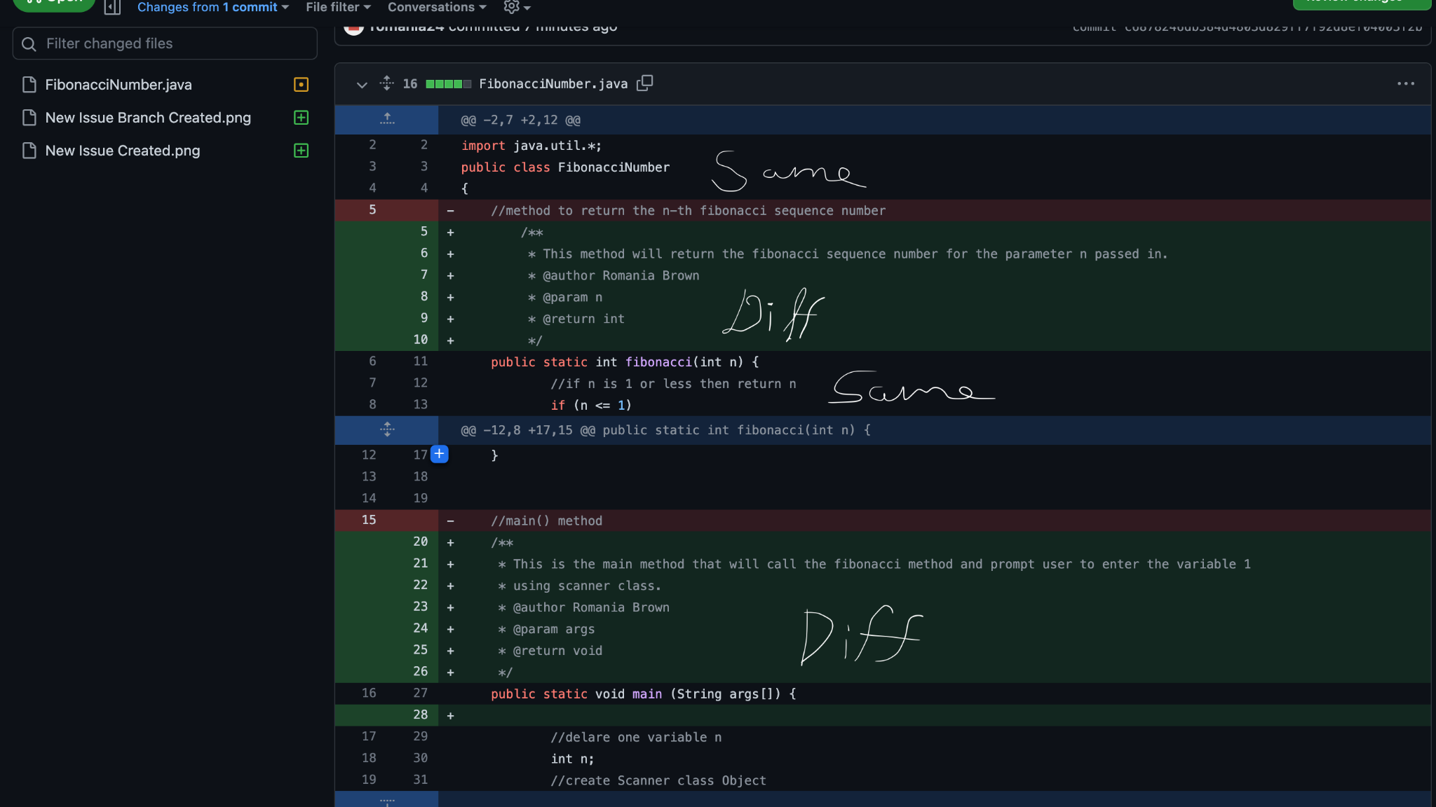

1. New Branch is deleted (issue branch) after merged in main.

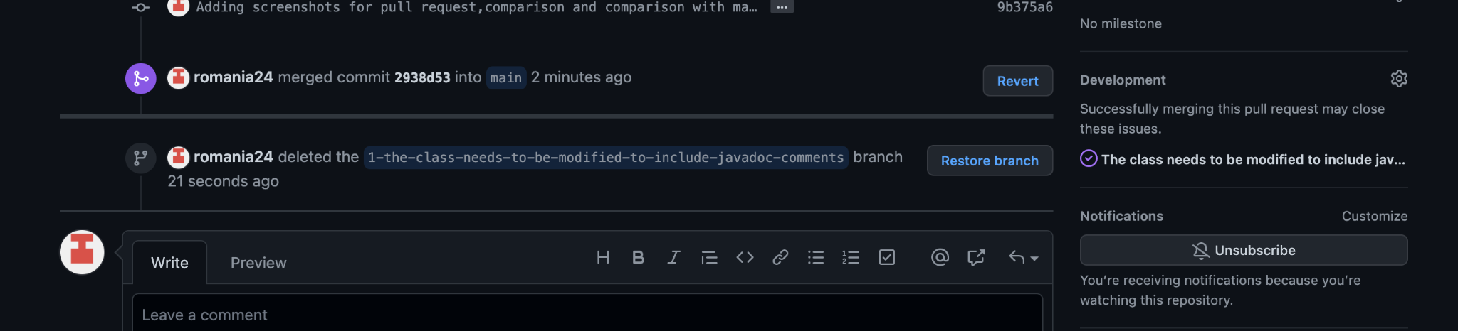

1. Final main branch is up-to-date and synced.

